T-Shirt Design & Markup Test
Fan T-Shirt Test Assignment:
You will create a t shirt for your test. You will create a design, pick a shirt, and price the cost of the shirt, the design, and any shipping costs. You will then markup the cost of the shirt to determine what you will sell it for. For this test, you will draw for designing either a senior shirt design, or a school store design.
Test Evaluation: Your design must have 2 or three colors
Design Directions: Create a t-shirt design that could be sold in the school store or to seniors (draw from teacher). Your target market should drive your decision on what design template you will use from the software. You can pick a template, or you can design from scratch. For the store shirt, you want it to meet the needs of students, staff, and parents not just one group. Senior shirts are one group.
- Would you enter a year on your shirts? Why or why not?
/5pts
- Review the pricing chart (a link found on our class webpage). If you were to order 50 transfers of your design, what is the estimated cost based on the chart:
1 color: 2 colors: 3 colors /5pts
- Why is the number of colors used to design your t-shirt transfer important?
/5pts
Design Your Shirt in Transfer Express.com
Login: Select Online Designer in upper center of page. Username: mm587 Password: marketing13
Select Online Designer again once logged in to get to the designer page.
- Add a Layout and selected from the school menu. Changed to fit MHS /5 pts

- Use your preferred Apparel color of t-shirt as your background color. Select the Apparel color from the bottom of the gray art board screen. Your shirt must work on three t-shirt fabric colors to fit your school. /10pts

Your preferred background shirt color is:

- Replace the text with Minot High related text and graphics. Use text that fits and represents Minot High School. Some examples include but are not limited to:
Minot High, Minot High School, Magicians, Magi, MHS,
Minot Public Schools, Minot /10pts
- Minot High Logos: If you picked a pattern with a logo, you need to replace it with a Minot logo. Or you can add one to your pattern (not required). To change a clipart: Click on the existing clip art and delete it. Select Add clipart to access cliparts. To add a Minot High logo, Select “Add” from the menu at the top, then select Customer Clip Art under My My Library.

- Change your text colors to Minot High Colors (1, 2, or 3 colors is best) /10pts

- Effect/Patterns: You need to add one effect, distress, or pattern to your artwork. Which one did you use and where did you use it?

/5pts
If you already have one added to the predesigned pattern you chose, you could remove it also if you feel it looks better.

- Test and ensure all graphics look good on all three shirt color options you chose. View these background color options in transferexpress.com to ensure all graphics will print on the shirts correctly. If something does not view correctly think about adding boarders, outlines, shadows that offsets the colors. /10pts

- Save your design to transferexpress.com as your Last Name Fan /5pts

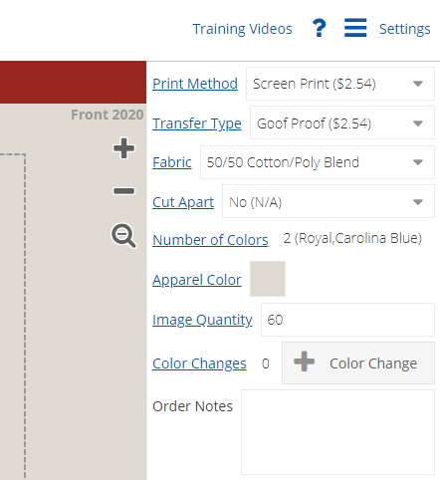
Design Cost: Determine the cost of your Design: On the bottom of the screen enter the quantity you will purchase as 50. Select Print method as screen print, transfer type as Goof proof. At the right the price per design will appear. It does not include the shipping. Total shipping for all 50 shirts is $18.00. You must calculate the per shirt price to determine the cost per shirt.

Reminder: Your design must be 2 or more colors:

Transfer Type | Per image Price | Shipping is $18.00. | Cost per item | Points:
Goof Proof on a 50/50 shirt |  |  |  | /6PT
Shirt Cost Directions: Go to Alphabroder.com and find a shirt and the cost per shirt.
Username: minothigh Password: marketing13
Use the Regular Pricing not the sale price for your shirts. Why did we use Regular pricing and not sales pricing to calculate cost here?
/10pts
Shirt Type | Item # | Fabric | Regular Price/Cost | Sizes Available
Short Sleeve | G800
Long Sleeve | 29L
Crew Neck | G180
Hoodie | G185
Shirt of Your Choice

Total Shirt Cost plus Mark up:

How many colors for your design did you have?
Did you test all three background colors to ensure you can view all design aspects?
Would you do this on Cotton polyester blends (50/50) of Performance wear (100% polyester)?
Directions: In the question above, for your shirt choice, if you selected a 50/50 blend shirt you will use the Goof Proof pricing on the previous page of the Design cost per item. If you selected shirt of your choice that was 100% Polyester, you use the Elasti Print pricing (change the goof proof option at bottom to elasti print). Calculate the suggested retail based on the markup options shown below.

 | Shirt Cost | Design Cost  (Based on 50) | Shipping  per shirt? | Total Cost | Retail at 50% markup | Retail at 80% markup
Short Sleeve Shirt
Long Sleeve Shirt
Crew Neck
Hoodie
Shirt of your choice
What do you recommend we sell our shirts for? Circle the price above in each column for each shirt option, either 50% or 80% that you think is the best pricing.
/30pts
- Print two copies of your design in color. Staple one to this assignment to hand in. Use the other to gather
voting in the cafeteria.
In Transfer Express, select Mockup. Select Download and it will download to a PDF. You must name the download. Just name it Store Shirt and your name. Open the download and select print.
/7pts

Use the shirt option of your choice. The one you think your target market will like the best and will sell the best. With the design you made, and the shirt you selected determine the following regarding your cost per shirt.
/6pts
- What is the cost (price + shipping) of the shirt?
Are you using 50 % or 80% markup?
- What is your Markup amount? `
- What is your retail price?
- What is the profit margin?
Overhead or Operating Expenses are 15% of gross revenue. Do you have a net profit or loss and by how much?
Net Profit or Net Loss? What is that amount?

Total Test Score: /135pts

